

User Manual
Expense Module
www.flowhcm.com



Contents
Expense Request 3
Upload Excel 5
View Report 6
Advance Expense Request 7
Advance Adjustment 9
Expense Approvals 10
Expense Settings 11
Expense Category 12
Expense Type 13
Expense Quota 15
Expense Rate 17
General Expense Settings 21

Expense Request

- Navigate to Others Tab and click Expense Module
- For Expense Request, click on Apply for Expense
- Select employee, category, month and year for expense
- Incase of request against advance select Yes in dropdown
- Set date and type of expense, enter amount
- User can add multiple lines in a single request
- System will show employees quota summary and history of expense in Table form
- Attach a file if required and check or uncheck include in payroll option
- Enter description and then submit the request

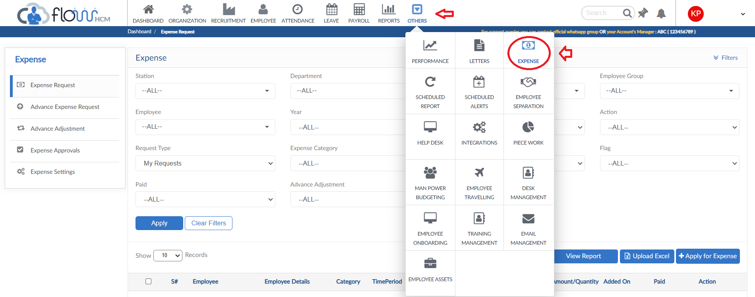

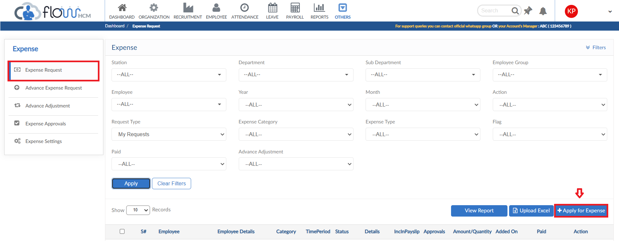
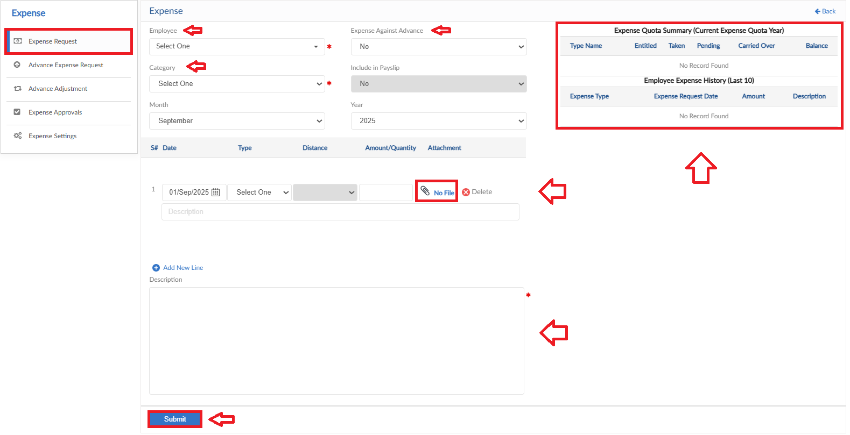

Upload Excel
- If required, upload all expense requests in one go user can use upload excel
- Click on Upload Excel button, pop up will be visible
- Then click on Download Sample Template and enter required data
- Click on choose file and then click on Save button to upload all Expense requests

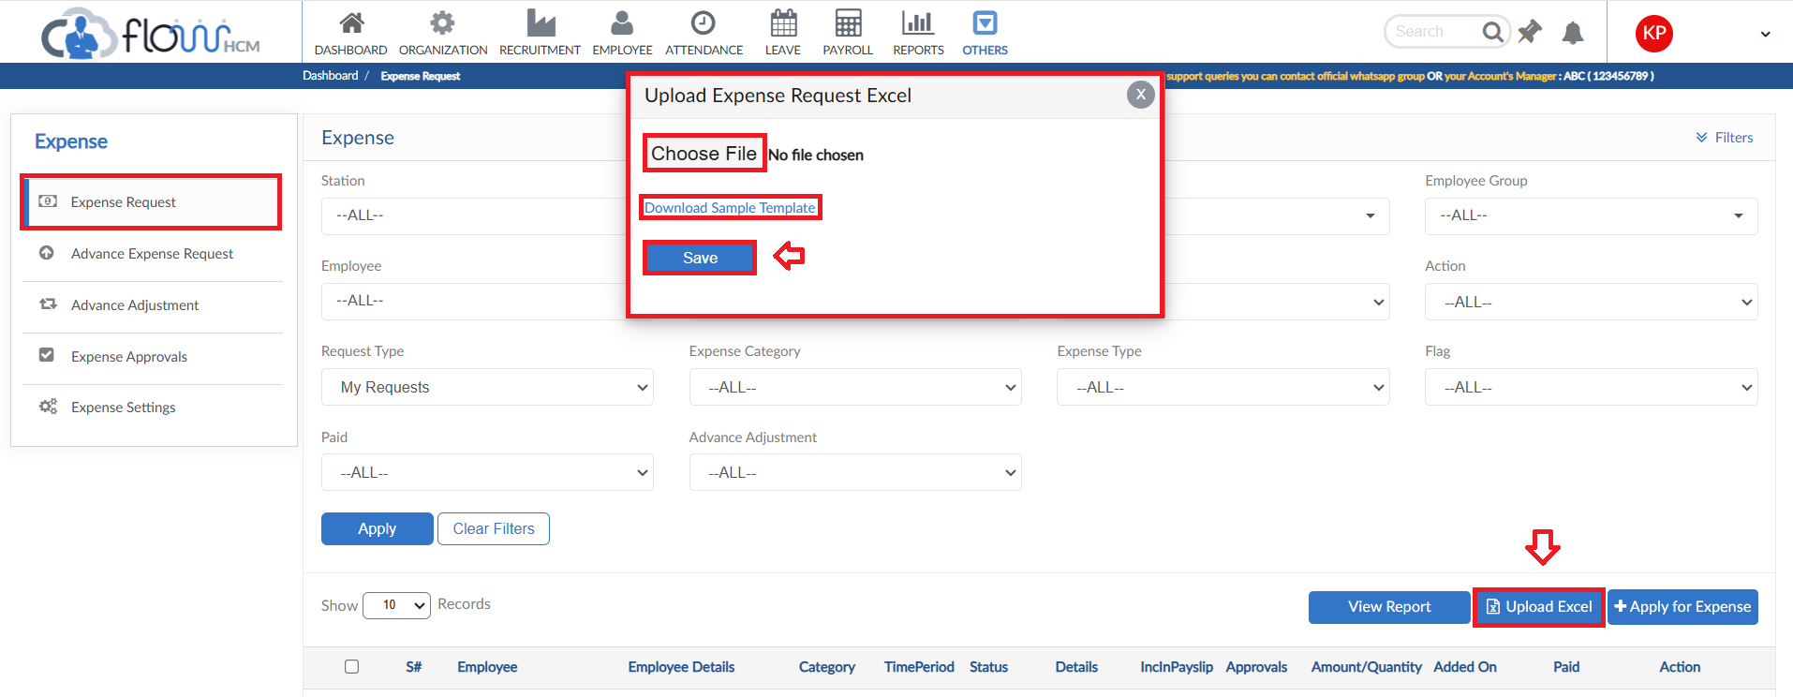

View Report
- To view the data of grid in Expense Request form click on view report
- Expense Request Report will pop up on screen
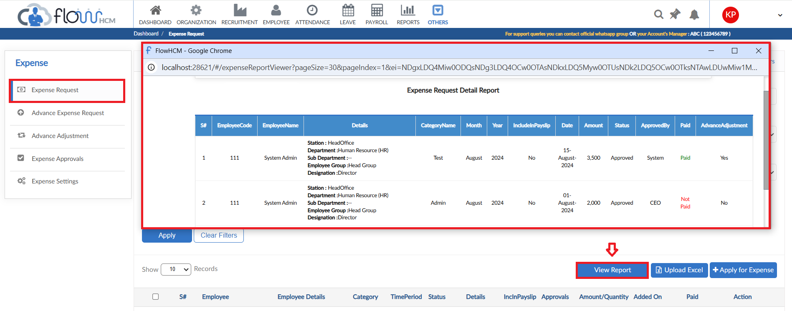

Advance Expense Request

- For Advance Expense Request, click on Apply for Advance Expense
- Select employee, category, month and year for request
- Set date and type of expense, enter amount
- User can add multiple lines in a single request
- Attach a file if required
- Enter description and then submit the request

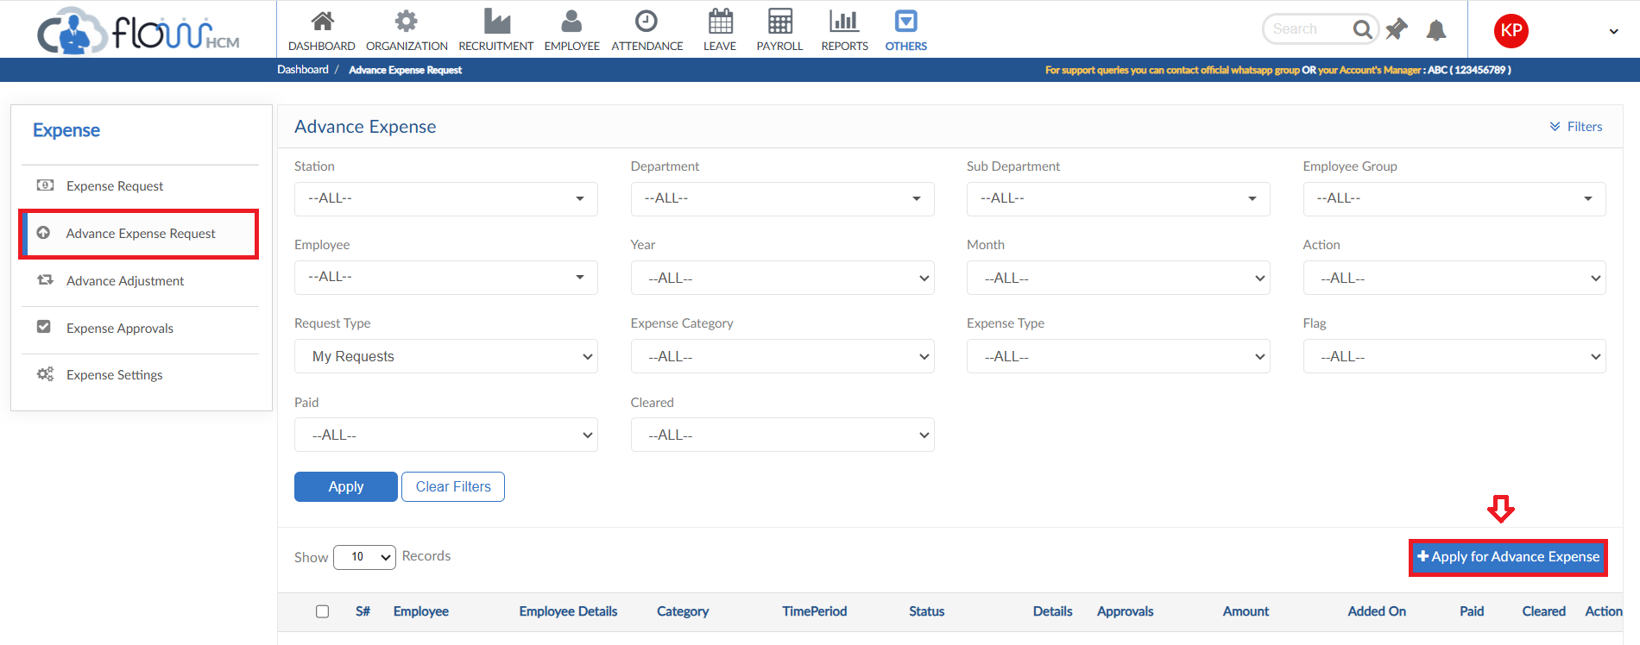

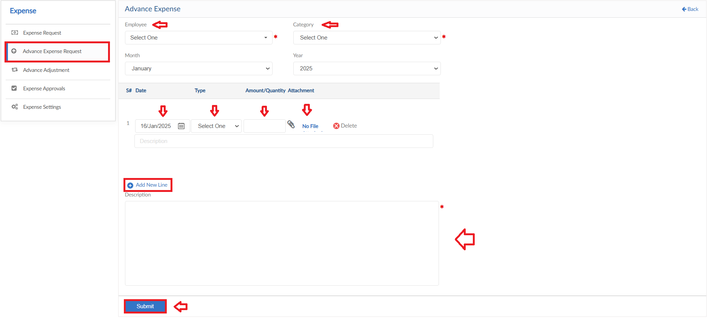

Advance Adjustment

- For Advance Adjustment Request, click on Apply for Advance Adjustment
- Select the employee and Category from dropdowns
- Define the type, system will show the Remaining amount
- Select the Operation from dropdown (Increment/Adjustment) and enter the amount
- Define a date and enter a reason for request
- Then click on submit to raise a requisition
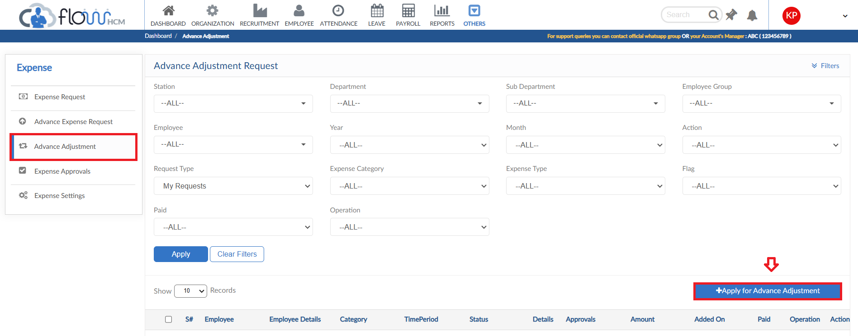
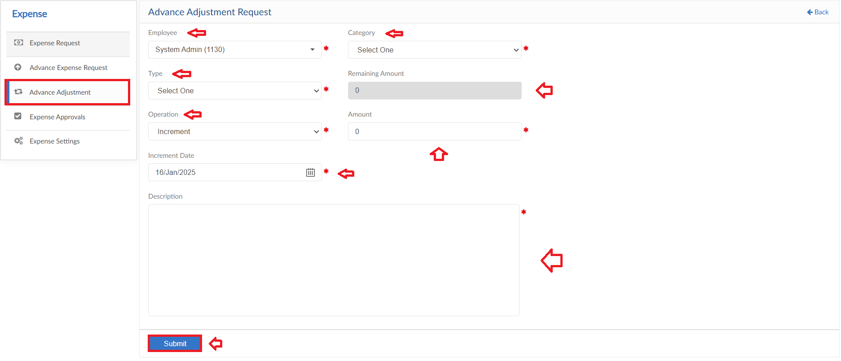

Expense Approvals

- Move to next tab of Expense Approvals
- In this screen all the expense requests will be listed
- Take action against the requests either approve or reject and enter comments
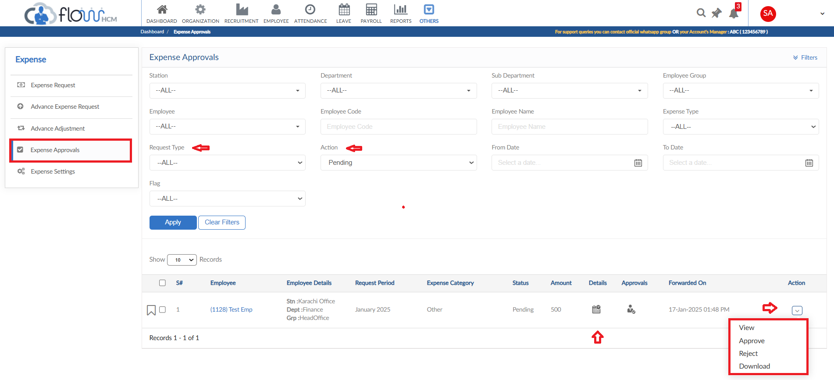

Expense Settings

- Expense Setting form consists of multiple setup forms
- Click on Expense Settings form
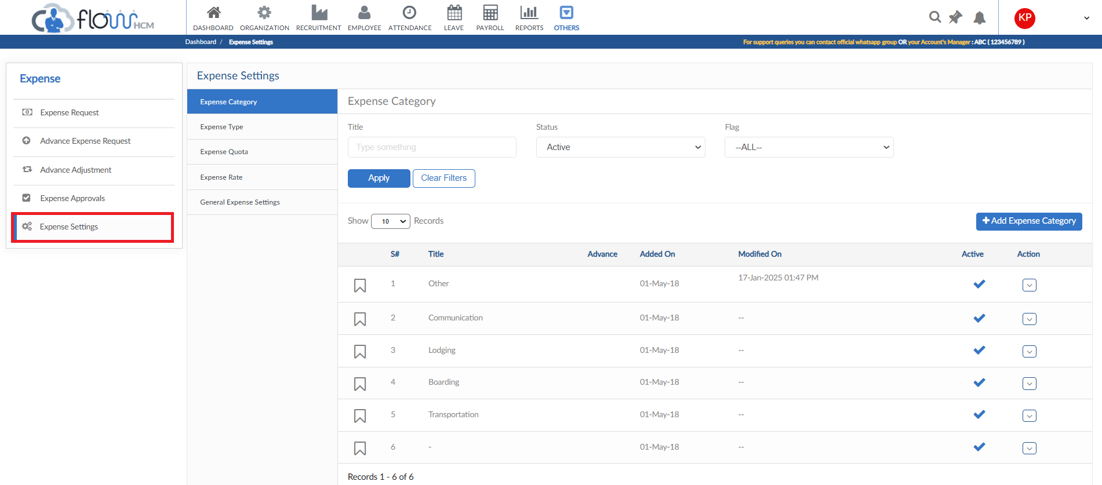

Expense Category
- Click on Add Expense Category button
- Pop up will be visible, enter title of category
- Select either this type will be used against Advance Expense or not
- Define either it will be included in payslip or not or both for user preference
- Can be Auto or Multi-level approval based
- Approval type can be Specific Employee or other
- Then click save button, it will be added in the list
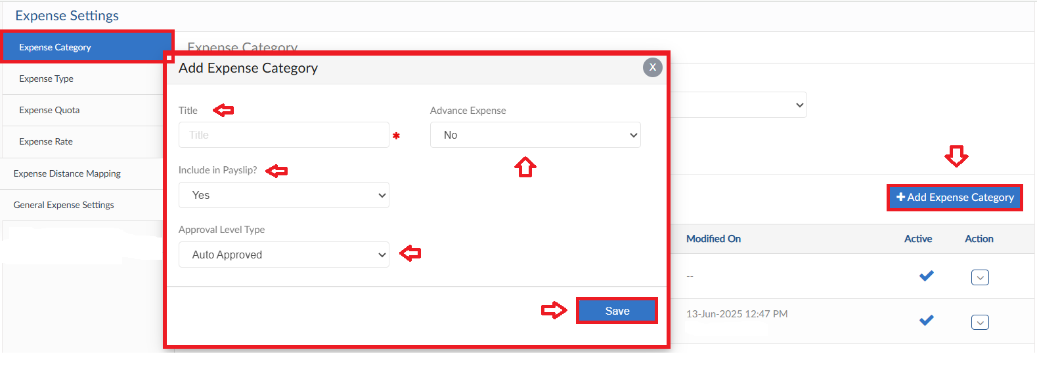

Expense Type
- Move to Expense Type tab, click on Add Expense type button
- Enter Expense Type Title
- Set all the parameters for that type then save
- Type will be added in the list
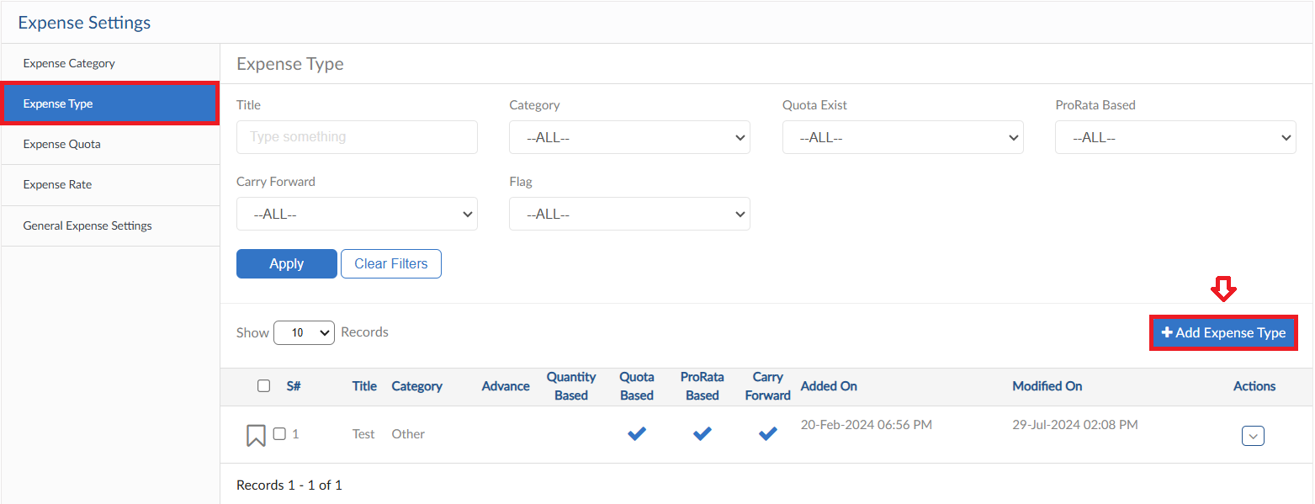
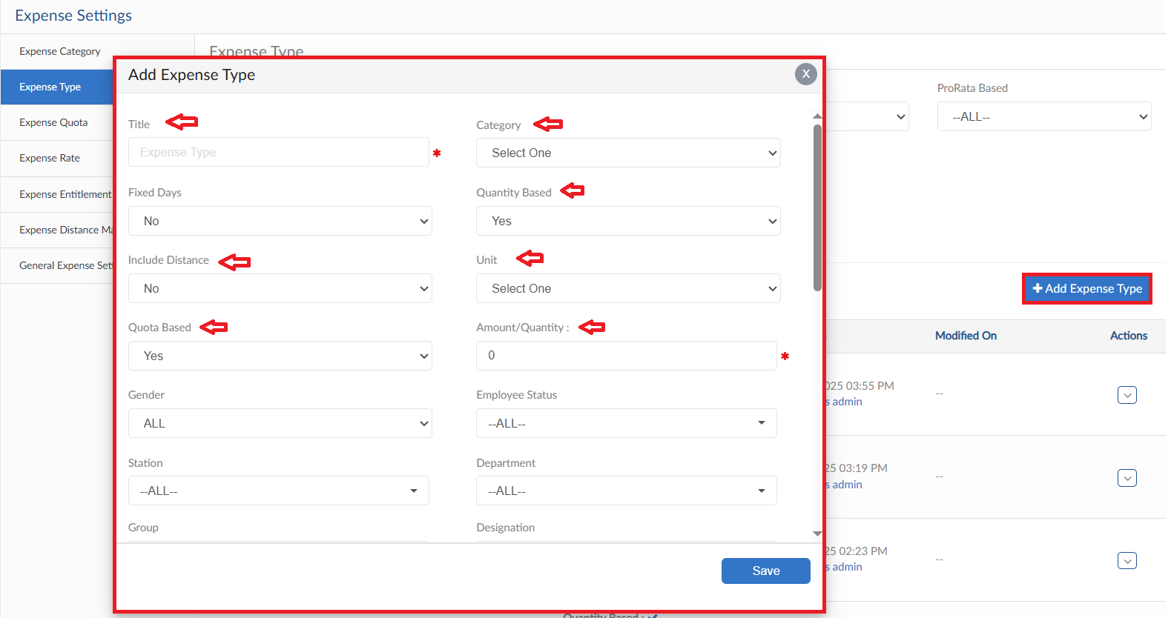
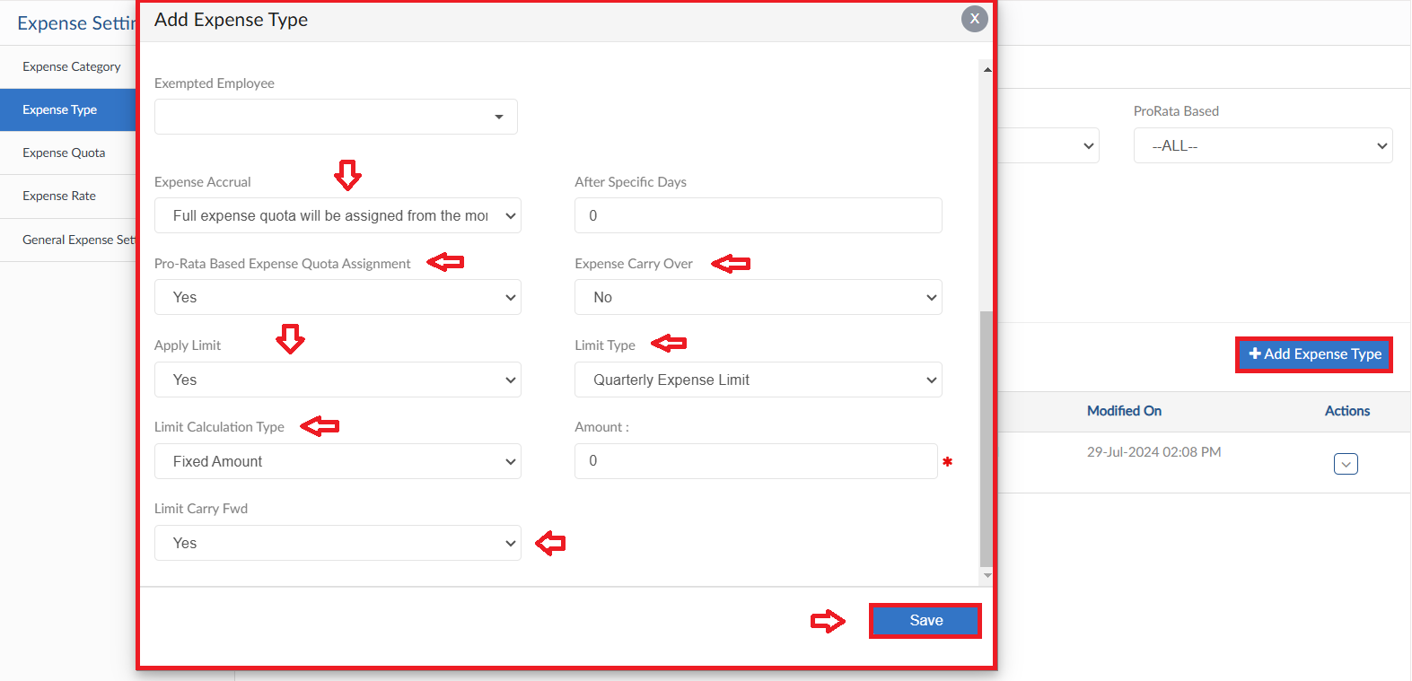

Expense Quota
- To create Expense Quota, click on Expense Quota form
- Select the required criteria and click on Apply button
- Then click on Create Expense Quota
- System will generate Expense Quota in accordance to the policy of Expense type
- Expense details are shown in grid, click on Update Leave Quota to assign quota

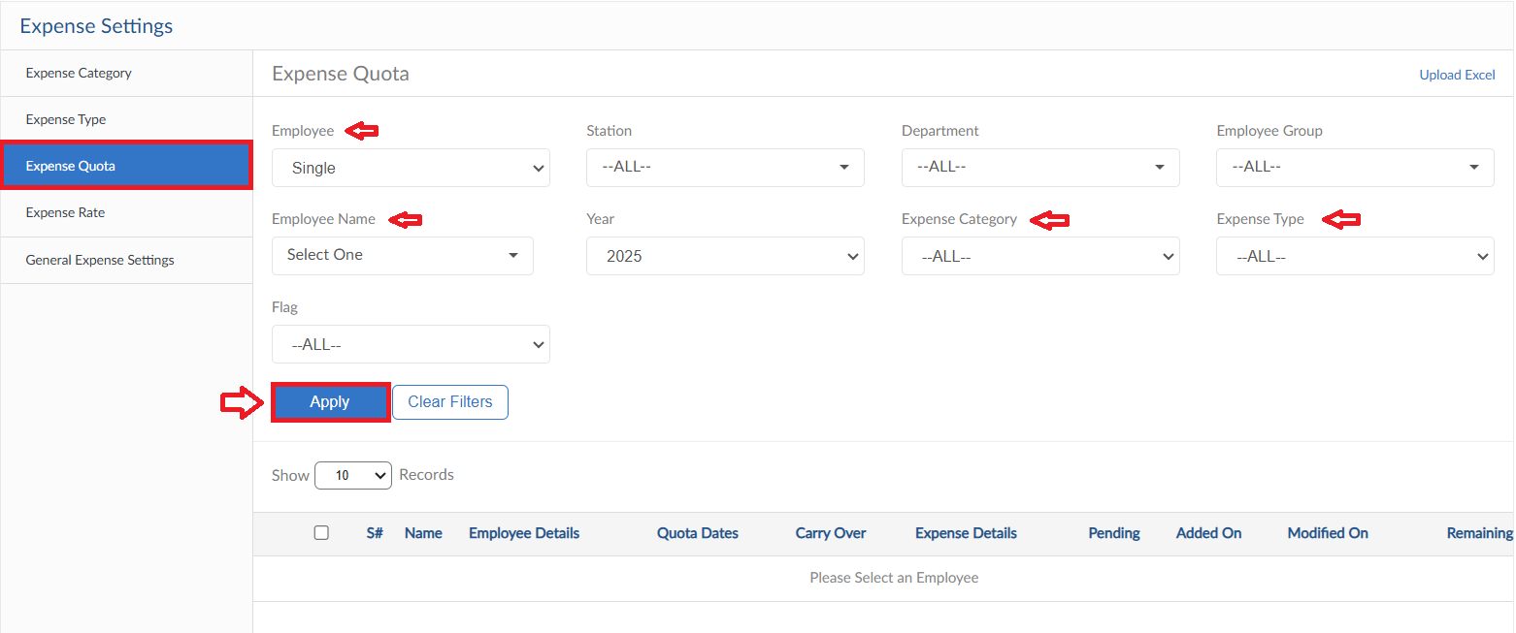
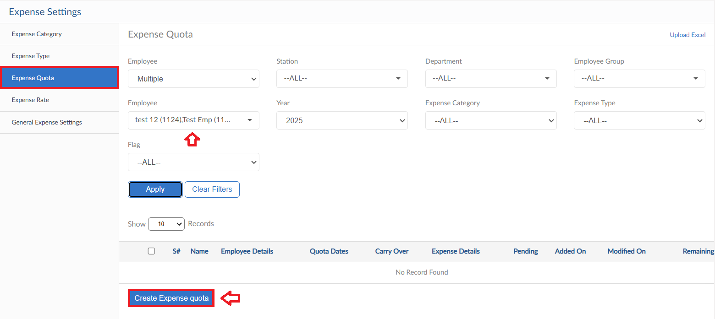
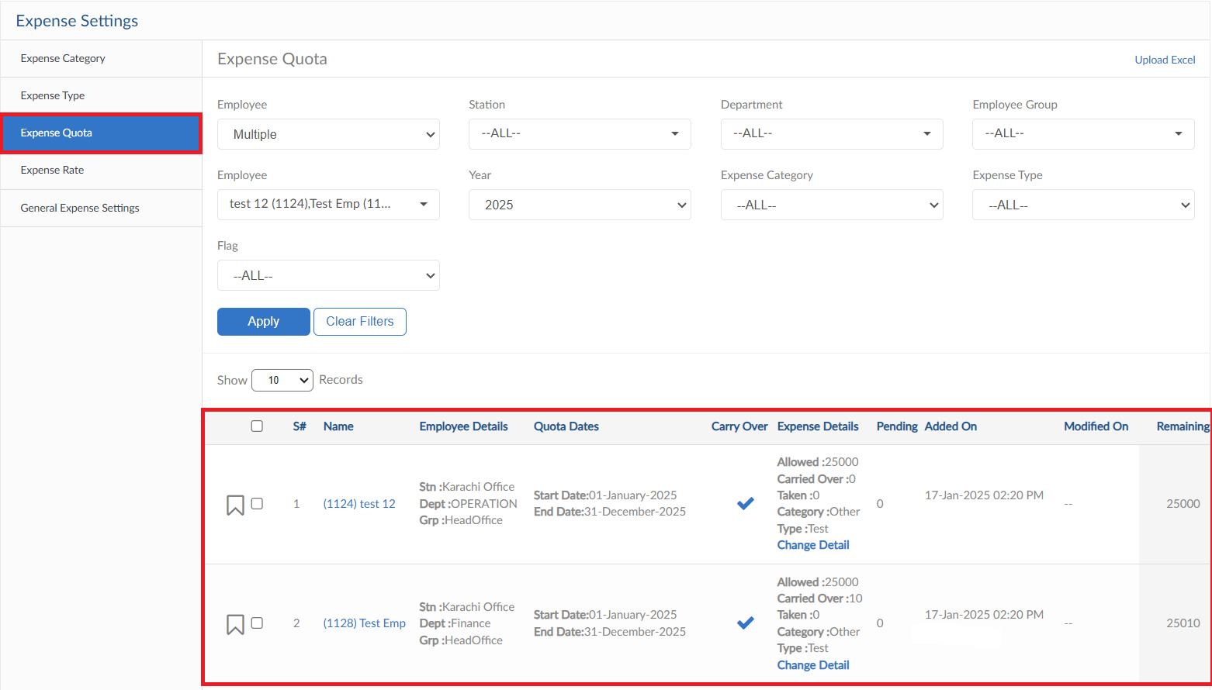

Expense Rate
- To add Expense Rate, click on Add Expense Rate
- A pop will be visible select the Title and employees from dropdown and enter the rate
- Define Month and Year for Allowance Rate then click Save
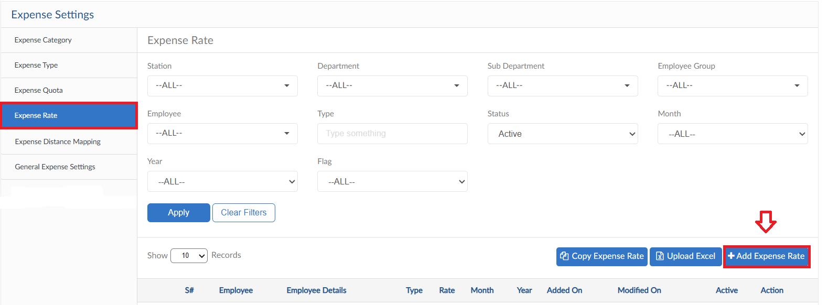
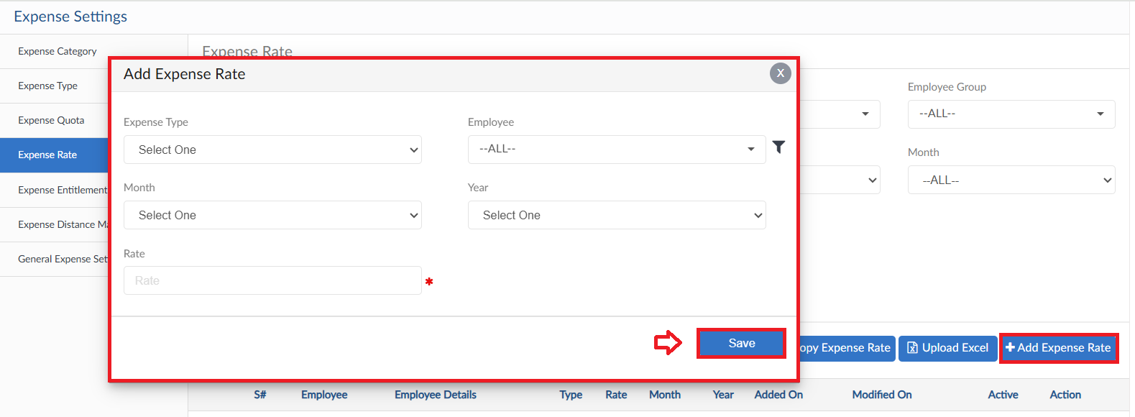

Upload Excel
- If required, upload all expense rate in one go user can use upload excel
- Click on Upload Excel button, pop up will be visible
- Then click on Download Sample Template and enter required data
- Click on choose file and then click on Save button to upload all Expense rate
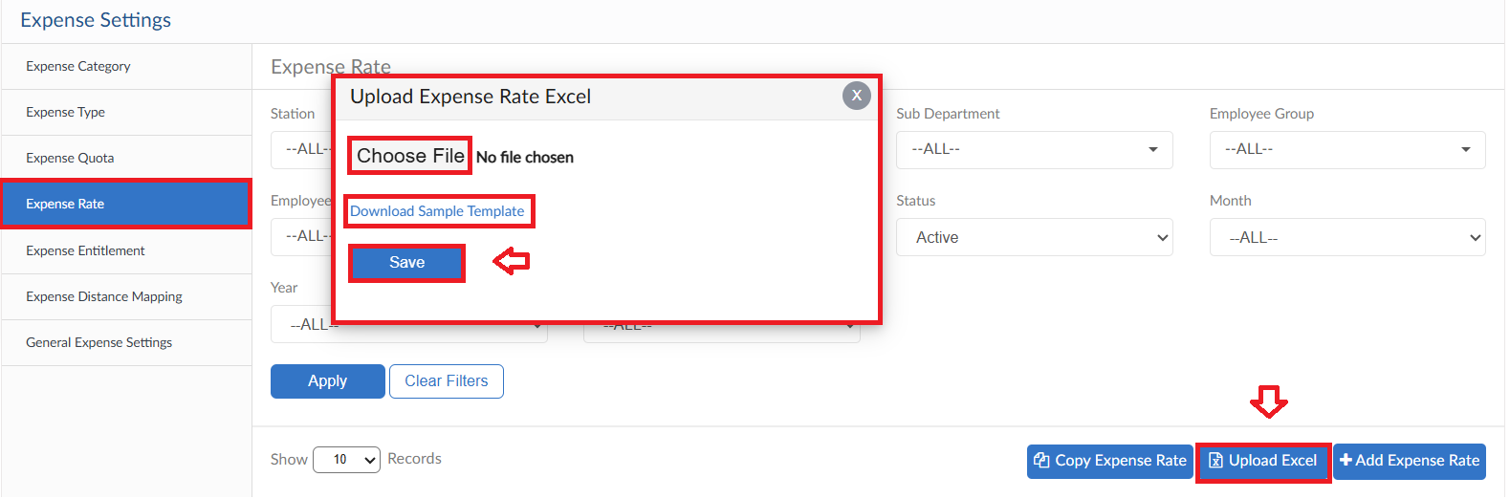

Copy Expense Rate
- To copy defined expense rates for upcoming duration click on Copy Expense Rate button
- Pop up will be visible, select the criteria and click on Save button

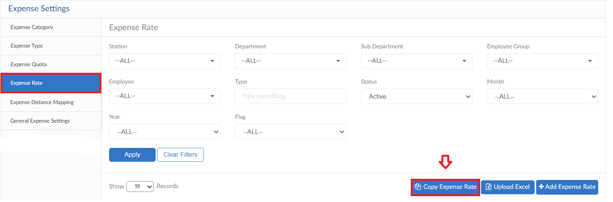
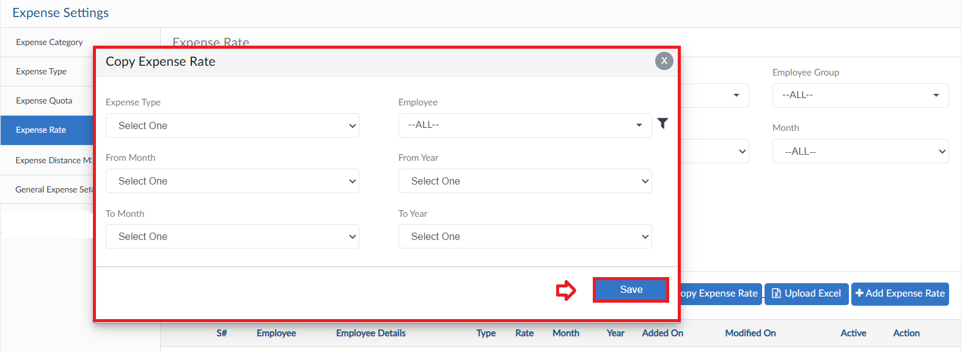

Expense Distance Mapping
- Click on Add Expense Distance button
- Select the Expense Type, City From and City To from dropdowns
- Enter the distance so that it will be calculated with the rate and unit
- Multiple lines can be added
- Click Save button
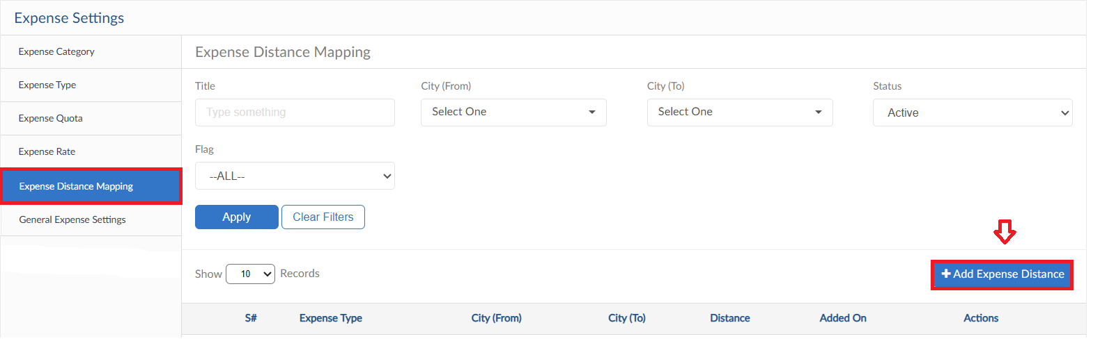
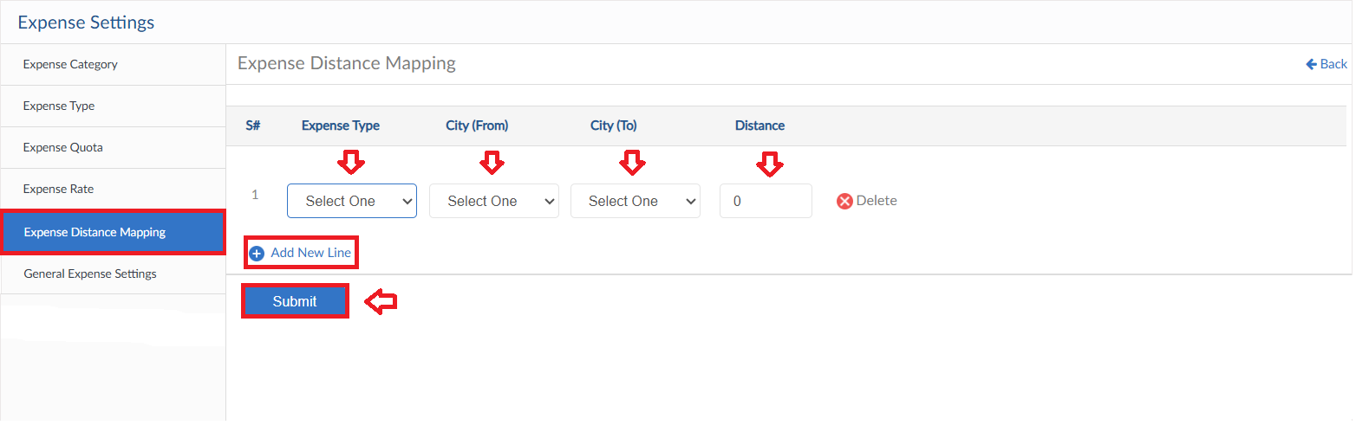

General Expense Settings
- Define the start date of Expense Quota in Expense Quota settings Tab
- Then click on save button
